





**Our Aim**

*“OUR AMBITION IS TO BE THE MOST CHILD FRIENDLY*

*BOROUGH IN THE COUNTRY”*

As part of the Children and Young People's Plan 2022-2025, Doncaster Youth Advisory boards' ambition is to make Doncaster the most Child Friendly Borough in the Country and by that; we mean a safe, happy, healthy, connected and inclusive place for all children and young people. This grant programme will enable us to strengthen and embed our Local Offer over and above our statutory duty to provide Short Breaks (support for parents and carers of children and young people with Special Educational Needs and Disabilities (SEND).

Doncaster Council has allocated £50K of capital funding for the implementation of a Short Breaks Capital Fund grant programme. The funding can be used for equipment for organisations who will provide regular, inclusive universal and targeted activities to support children and young people with special educational needs and disabilities. This will result in an improved range, capacity and availability of activities across the borough. The equipment bought must be maintained and kept in working order and used for the benefit of children with Special Educational Needs and Disabilities (SEND).

**Statutory Responsibility**

Section 25 of the Children and Young Persons Act requires local authorities to provide short breaks for families with disabled children. This is set out in the Breaks for Carers of Disabled Children Regulations 2011 (or Short Breaks Regulations 2011), which require local authorities to do three things:

* To ensure that, when making short break provision, they have regard to the needs of different types of carers, not just those who would be unable to continue to provide care without a break;
* To provide a range of short breaks, as appropriate, during the day, night, at weekends and during the school holidays; and
* To provide parents with a short breaks services statement detailing the range of available breaks and any eligibility criteria attached to them.

**Who can apply?**

Applications are open to Voluntary, Community and Faith organisations, specialist organisations, Charities, CIC and private companies, providing activities for the target group within the City of Doncaster. We can award grants to any eligible organisation in the Doncaster community who are delivering universally inclusive activities and services to the children and young people with SEND as long as:

* The grant does not result in any personal/private benefit.
* Any income generated from the project funded is re-invested into the project and is not used for any other purpose.
* We will need to see the organisation’s governing document e.g. constitution or Memorandum and articles of association, signed and dated, which include an appropriate dissolution clause.
* A copy of your most recent accounts (less than 1 year old) which have been approved, or projection figures if you are a new organisation.
* A bank statement for the account the grant will be paid into which is less than 6 months old
* Copies of quotations for any items or works over £1,000.
* Relevant permissions would need to be evidenced for any physical works taking place in a property.
* Safeguarding Policy.
* First Aid.
* Risk Assessments.
* Liability insurance.
* H&S policy.

**Who cannot apply?**

We cannot grant awards to the following:

* An individual or sole trader.
* A Gambling Club.
* A Political Organisation.
* Organisations looking to fund activities outside of Doncaster.

**What can be funded?**

We can potentially fund any project which supports the delivery of activities and services for children and young people with SEND outcomes following priorities outlined in the Children and Young People’s plan 2022-2025 and follow our Be Kind ethos.

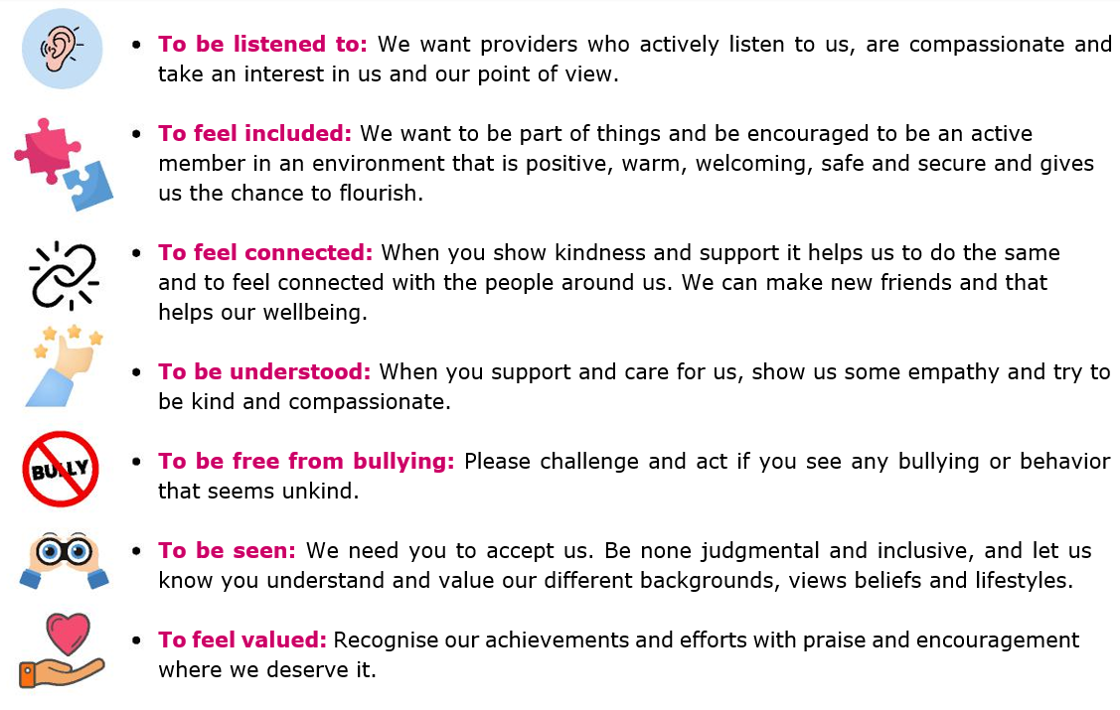

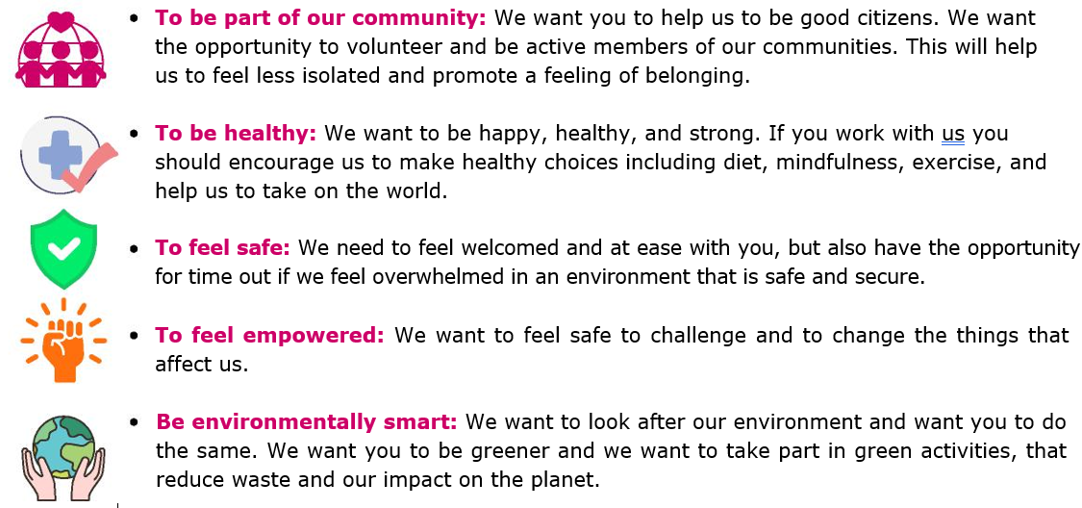

Please follow link for further details:

[Children and Young People's Plan 2022-2025](https://www.google.com/url?sa=t&rct=j&q=&esrc=s&source=web&cd=&ved=2ahUKEwiJwNmMstuIAxVdZ0EAHafEDQAQFnoECAcQAQ&url=https%3A%2F%2Fwww.doncaster.gov.uk%2FDocuments%2FDocumentView%2FStream%2FMedia%2FDefault%2FChildrenYoungPeopleFamilies%2FDocuments%2FCYPP-2022-LR2.pdf&usg=AOvVaw2ZCzrMsPglC20sekt0k8fI&opi=89978449)

**What we will not fund….**

* Professional fundraisers
* Capital contingencies
* Gifts and entertainment
* Faith based activity, that can’t demonstrate wider community benefits.
* Outstanding Debts
* Automatic continuation costs
* Animal and or plant activity that can’t demonstrate wider community benefits
* Overseas travel costs
* Retrospective Action
* Staff costs
* Revenue Funding
* Works that do not comply fully with procedures for building/planning/health and safety regulations.
* Any works to a building that cannot demonstrate the appropriate permissions are gained.

This list is not exhaustive. If you are unsure whether you are eligible for funding or if you need any clarification, please contact [SBCapitalGrantFund.Applications@doncaster.gov.uk](mailto:SBCapitalGrantFund.Applications@doncaster.gov.uk)

**The Basics**

* Deadline for your submissions is **5th February 2025**
* The maximum amount organisations can apply for is **£5,000**
* Grants must be spent as stated within the Grant Approval notification.
* All funding must be spent by **31st March 2025.**
* Activities must be published on the Local Offerby **30th June 2025**
* Evaluation submitted by **21st July**
* The grant can’t be used to fund costs incurred prior to the date of the grant approval.
* You will be required to produce evidence that the grant has been spent in line with your Grant Approval. Failure to provide this information will result in your organisation being required to pay back to the Council the value of any grant expenditure that can’t be evidenced.
* The applicant must be able to demonstrate impact: that the project represents good value for money and benefits SEND children and young people of Doncaster.
* The successful applicant must make available for inspection by a representative of the Council on request, financial records to evidence appropriate spending of the grant.
* All policies and supporting documents listed on the application **must be submitted along with the application for it to be considered.**

**The Application Process**

|  |  |
| --- | --- |
| **Application Guidance and due-diligence** | Each question will carry a score so please complete fully and where possible, please give examples. You must also submit along with the application all the requested policies and procedures, as checks will also be completed on these, so ensure all documents are dated and in date. Applications will not progress without compliant documentation. |
| **Applying** | To request an application please follow link.  <http://www.doncaster.gov.uk/services/schools/short-breaks-capital-equipment-grant-fund>.  Please return to [SBCapitalGrantFund.Applications@doncaster.gov.uk](mailto:SBCapitalGrantFund.Applications@doncaster.gov.uk) |
| **Eligibility** | We will initially check your application to ensure that your organisation/project is eligible for funding. If it is, your application will proceed to the appraisal stage. If it isn’t you will be informed why your application is ineligible for a grant and where appropriate, directed to other possible funding sources. |
| **Appraisal** | The Short Breaks Grant Fund Panel will appraise your application to determine whether it meets the objectives of the Short Breaks Capital Equipment Grant Fund and whether it represents value for money. You may be contacted for further information regarding your application. When the appraisal process is complete, your application will be considered. |
| **Decision** | Final approval will be made by the Panel. All applications will be assessed against the following criteria:   * Quality of project opportunity. * Benefits of the project to Children and Young people with SEND. * Alignment to the Children and Young People’s Plan, beneficial for Short Breaks legislation/statement. * Value for Money. * Number of Beneficiaries.   If your application is successful, you will be informed by email and will then receive a Grant Offer Letter that will.  If your application is unsuccessful, you will be informed by email.  You would also need to ensure that all subsidies are disclosed and that your Grant Agreement is signed. |

**The Appeals Process**

Any decision made on an application is final.

Due to the anticipated number of applications, it may not be possible to provide individual feedback on each decision.

However, any enquiries regarding the handling of the application should be sent to:

**Mailbox** [SBCapitalGrantFund.Applications@doncaster.gov.uk](mailto:SBCapitalGrantFund.Applications@doncaster.gov.uk)

**Bobby Johnson** Commissioning Officer [bobby.johnson@doncaster.gov.uk](mailto:bobby.johnson@doncaster.gov.uk)

**Dean Mangham** Commissioning Lead [dean.mangham@doncaster.gov.uk](mailto:dean.mangham@doncaster.gov.uk)